Family Emergency Plan Customization Guide

Purpose:
The purpose of this document is to enable you to quickly create a Family Emergency Plan that you can use for your family, your location and the unique sources of risk to your family’s survival in the event of disaster. This plan will not protect you from Nuclear War, Bad Judgment or Irritating People. However, some of the parts of it could be used to assist in those events as well.

Process:

Using the table below, you can quickly replace the Generic Value in the document with the Specific Value for your family. Once you have replaced all of the Generic Values with your Specific Values, then the real work begins. But you and your family will already be better off.

Step One:
Make the commitment to your family and get organized. Assign someone to manage your family’s plan. Divide up the research and acquisition tasks to complete the plan and build your family’s Emergency kits.

Step Two:
Edit the plan. Do the research. Gather the information you need to complete your family’s specific plan. Inventory what you have for your emergency kits Accumulate the materials your family will need to survive if you evacuate and shelter in place (without any services).

Step Three:
Hold a family meeting to review the plan as you have completed it. Have you accounted for all likely scenarios? Have you accounted for all of the people and likely situations they would be in should an emergency event occur? Does everyone know what is in your Emergency Kits and where they are?

Step Four:
Conduct a walkthrough drill with the entire family. Pay attention to details you may have overlooked. The goal is the gain confidence in your plan and identify any holes that you can.

Step Five: Maintain it. Batteries have to be replaced from time to time. Family members situations change. Johnny broke his ankle, how does he evacuate in a fire now? Susie has started Jr High and has a new set of emergency contact numbers. Should the emergency meet up place change because of her new schools location?

Global Edits:

You can do global edit to find and replace the following generic values in the document to customize it to fit your family (e.g. Find on Family and Replace with Jones if your family’s last name is Jones> Replace All).

Apple Pages Global Edit:
Generic Value to Change

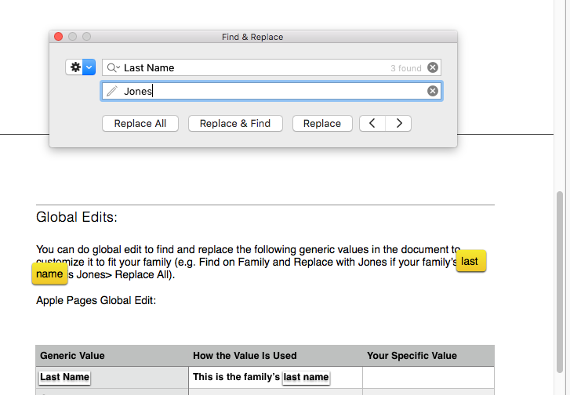
Replacement Value
Scope of Change
You simply enter the Generic Value from the Table below, type in the customized value for your family’s Emergency Plan and select “Replace (All, Replace & Find (means one at a time) or Replace ( the one that is highlighted next only)).

Microsoft Word Global Edit

The process is the same in MS Word but the menus are a bit different.

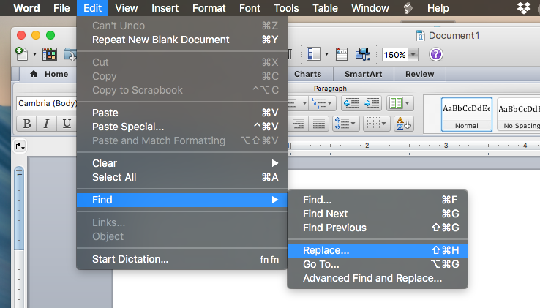

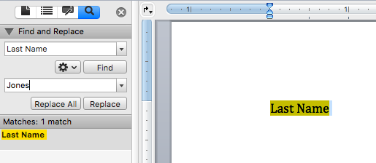

The procedure is exactly the same. You can replace all or just the next highlighted value you have in the Find box.

The following generic values have been used throughout the document that you can find and replace with your specific values to create your own Family Emergency Plan.

Generic Value | How the Value Is Used | Your Specific Value
Current Date | This populates the date after “Updated:” This date allows all readers know when the plan was last updated.
Last Name | This is the family’s last name
Our Town | This is the municipality you live in
Our County | This is the county you live in
Our State | This is the state you live in
Power Company | This is your electric and gas company
Our Trans | This is your transportation department (ie. CalTrans or VDOT or ??

Edit Notes:

Embedded Links: There are numerous links. We have tried to preserve the link but you will need to check and maybe edit/change the links to point to your online resource.

Home Floor Plan Diagrams: I have left our family home’s diagrams to demonstrated the level of detail and information that I thought was helpful. You should replace these with your own diagrams, You can also add photos of key elements you wish to convey.

Special Considerations: I left our family’s special considerations as examples in Italics. Please replace these entries with any of your own or enter the word “NONE”, so you and others will know it was not overlooked.

This is a present provided with the best of intentions. It is not perfect nor is it anything like complete for your family. But it is valuable and will appreciate in value if you invest in it.

Why not start out 2018 more prepared to protect your family than you were in 2017?

Good Luck!

The McCann Family.

